**Spring Concept:**

This concept uses energy stored in springs to counter the force due to gravity. This concept can be implemented in two ways: Using a single spring for each joint, or a combinations of springs on each joint.

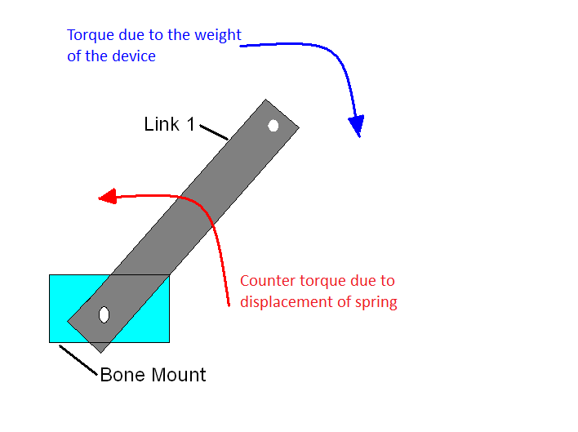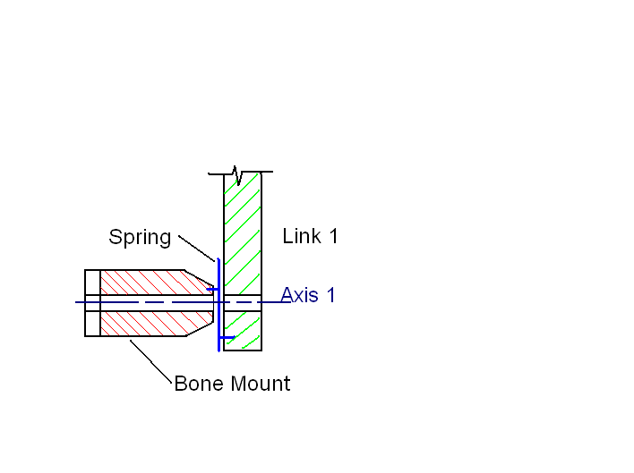

Having a single spring on each joint would be able to exactly counter gravity at a datum; however, when the device is closer to the surface than the datum, the device will return to the datum when released.

The other option for this concept is to have a combination of springs on each joint that could be adjusted to exactly counter gravity at any point in the link's rotation [1]. With this setup the device would remain stationary regardless of its position if the user released it. This setup also has the potential to be adjusted in such a way that it too could return to a datum if desired.

Advantages / Disadvantages

Some of the advantages to the spring concept are as follows:

* Relatively light weight
* Highly adjustable
* Predictable

A possible disadvantage to this concept is that it could require the user to overcome the force of the spring to move closer to the surface (for the datum setup)

**Work Cited:**

1. Barents et al, *Spring- to-Spring as Energy-Free Adjustment Method in Gravity Equilibrators*, 2009

**Winnowing**

The first stage in the concept evaluation is to remove concepts that are obviously not worth pursuing. This next section will consider each concept and whether that concept should be pursued further, possibly be combined with another concept, or no longer be considered.

High Friction Joints:

This concept has a serious flaw in that it requires the user to overcome the force of gravity as well as the force of friction in the joint in order to move the device away from the surface. For this reason the friction joint concept will no longer be considered.

Dampers:

This concept would not be able to achieve the desired outcome on its own; however, it does have the potential to be added to another concept in order to accomplish the required outcome. The damper concept will not be further pursued on its own, but it will be considered for future improvements to other concepts.

Counter Weight:

The counter weight concept makes it very difficult to achieve the goal of minimizing the total weight of the device. Although it may appear that this concept will not allow for all requirements to be met, it will still be considered in the later stages of concept evaluation.

Motors:

The primary concern for the motor concept is the complexity of its implementation; however, in order to properly evaluate our ability to successfully implement this option more information is still required. For this reason the motor concept will still be considered in later stages of concept evaluation.

Springs:

This concept is the early favorite and will be developed further.

**Validation**

Regardless of the concept chosen it needs to be validated before it can be implemented in the final design. The following section will explore how the chosen concept(s) will be validated.

The best way to validate a concept would be to develop a quantitative experiment to measure the performance of the concept. The function that these concepts have been developed for primarily has a qualitative component to it (does the device move without input?); however, the overall performance of the concept can also be measured quantitatively (How much force is required to move the device?). So the experiment used to validate a concept should consist of two parts. The first part to test whether the device remains stationary without input in multiple different orientations and the second part to measure the force required to move the device to predetermined orientations.

In order to simplify the experiment , only two degree of freedom motion needs to be considered (the linear slide is parallel with the ground, so it does not need to be considered). Even though this concept could be proven using just one link, both should be considered to ensure that there is no unwanted coupling effects between the two links.

Other validation criteria should include the total weight of the concept and the concept's ability to be sterilized.